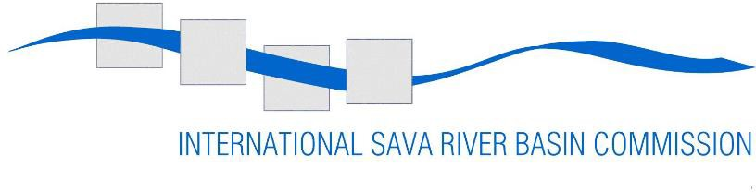

Reference: Job Application – Special Advisor for Legal and General Affairs
Publication: 21 January 2026
Deadline: 09 February 2026

Vacancy Notice
for the position of

Special Advisor for Legal and General Affairs
The International Sava River Basin Commission (Sava Commission) invites interested candidates to apply for the post of Special Advisor for Legal and General Affairs (Special Advisor) in the Secretariat of the Sava Commission.

The job and key accountabilities
Special Advisor will perform duties in the Seat of the Sava Commission in Zagreb. In this role, (s)he will have the responsibilities noted below.
Special Advisor:
  - Assists the Executive Secretary in all legal and general affairs;
  - Assists Executive Secretary deputies in performing their duties;
  - Advises the Sava Commission on legal and international law matters arising;
  - Participates in preparation of the Sava Commission sessions;
  - Prepare and supervise legal documents for the Sava Commission;
  - Provides legal advice on diverse substantive and procedural questions which may include those related to administration and management, institutional support, procurement and contracts,
  - Has responsibility for the preparation and organization of meetings of the Sava Commission’s legal expert group;
  - Participates in activities of other expert groups related to his/her scope of work;
  - Participates in the preparation of project applications, tender documents and contracts within his/her competencies;
  - Participates in maintaining contacts with appropriate government officials, institutions and international organizations to facilitate consultation and cooperation on all legal and international law matters pertaining to the objectives of the Sava Commission;
  - Performs operational communication with the authorities of the Host country related to immunities, privileges and international status of the Sava Commission and its personnel;
  - Follows up on legislation of the Parties important for the work and objectives of the Sava Commission;
  - Participates in the work of international organizations and bodies related to all legal and international law matters pertaining to the objectives of the Sava Commission;
  - Performs other tasks and duties as assigned by the Secretary.

Required attitudes and characteristics
  - Ability to exercise a high degree of professional initiative;
  - Ability to analyse complex situations, grasp the critical aspects, and propose timely and adequate solutions based on sound judgment;
  - Communication skills, including report writing and editing as well as oral presentation;
  - Ability to set challenging goals for him/herself, maintain focus on results, overcome obstacles and take responsibility for the results achieved;
  - Responsibility, loyalty, political and diplomatic tact;
  - Ability to work in a multidisciplinary environment with respect and sensitivity for diversity.

Eligibility criteria
The applicant must:
  - be a national of the Republic of Slovenia;
  - hold a level of education that corresponds to completed university studies of at least 4 years attested by a diploma (equivalent to 300 ECTS) in Law;
  - have a minimum of eight (8) years of professional experience relevant for the post after obtaining a university degree diploma stated out above.

Essential knowledge, skills and experience
  - Excellent command of both written and spoken English and one of the official languages of the Sava Commission;
  - Excellent understanding of the FASRB and related protocols, and the Sava Commission’s status and role;
  - Good knowledge of international conventions, treaties and EU legislation relevant for the functioning of the Sava Commission
  - Computer skills (MS Office programs);
  - Valid B driving license.

Knowledge, skills and experience that would be taken as an asset
  - Working experience, preferably 4 years, relevant for the post in an international body or national agency/organization;
  - Experience in bilateral and international relations.

Application procedure
For applications to be valid, candidates must submit:
- letter of application,
- curriculum vitae, using the attached Sava Commission CV form,
- citizenship certificate/copy of passport/ID,
- copy of diploma(s),
- proof of meeting the minimum requirements of professional experience (work certificates or employment contracts) and
- three reference letters

by post to

International Sava River Basin Commission Kneza Branimira 29, 10 000 Zagreb, Hrvatska or
by e-mail: isrbc@savacommission.org

With reference: Job Application - Special Advisor for Legal and General Affairs

The closing date for submission of applications is February 09, 2026.
Only complete applications will be considered.

The letter of application, curriculum vitae and reference letters can be written in English or in any of the official languages of the member countries of the Sava Commission. The letter of application should contain inter alia an explanation of why the applicant considers himself/herself suitable for the post, with a focus on the background and experience related to the position’s requirements.

The Sava Commission reserves the right to extend the closing date of this vacancy by publishing a notice on its official website: www.savacommission.org.

- Selection procedure
The section will be carried out in two phases against the criteria detailed in this vacancy notice. In the first phase, a Screening Committee, established by the Sava Commission, will analyse applications to verify the eligibility of the candidates and to assess their compliance with the requirements specified in this vacancy notice.
Failure to fully comply with one of the eligibility requirements shall result in the exclusion of the applicant concerned from the selection procedure. Applications sent after the closing date and/or incomplete applications will also be excluded.
In the second phase, candidates whose applications fully comply with the eligibility requirements will be invited to:
  - an interview to assess the candidate's ability to carry out the tasks of the post;
  - a test aimed at evaluating the candidate's knowledge of the English language (in-house testing at the time of the interview).
The candidates will be assessed against the essential requirements (Section 4) and the specified advantageous requirements (Section 5).

Medical Standards
As a precondition of appointment, the successful applicant shall be required to submit a health certificate issued by an authorized medical institution that he/she meets the medical standards set for appointment in his/her country of origin.

Appointment
The Special Advisor shall be contracted for a period of 5 years, including a six-month probationary period, with the possibility of subsequent extensions, provided that the Sava Commission agrees. The position is subject to the internal legal documents adopted by the Sava Commission, including the Staff Regulations of the Secretariat.

